**Waite First Securities**

Dear Alex,

I hope this email finds you well. I wanted to convey my gratitude for trusting us with the task of guiding you through the investment decisions. In this document, you will find three investment options: Apple (AAPL), Intel Corporation (INTL) and Kroger (KR). We have done our analysis for their performances, and we will provide detailed recommendations to help you with your investment objectives.

Below, you will find the three stock performances based on the data retrieved from Yahoo Finance from the year 2015 – 2020. We calculated various variables, such as arithmetic mean, geometric mean, standard deviation, coefficient of variation (CV), beta and coefficient of determination ($R^{2}$).

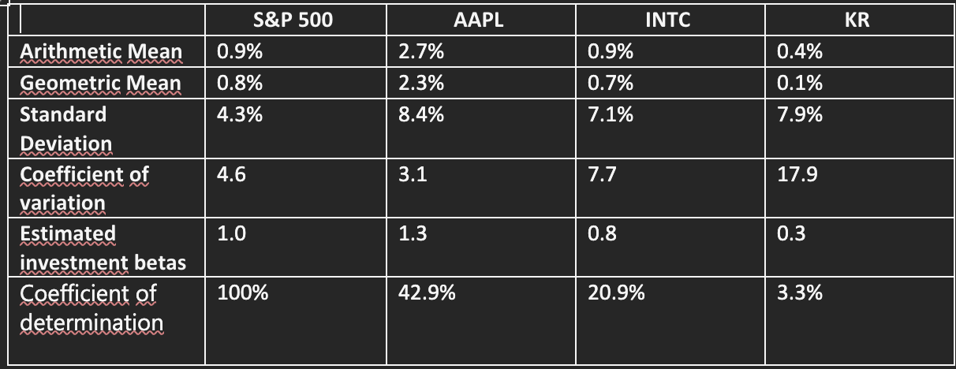

Please allow me to explain what each variable means. The arithmetic mean defines the average monthly return for each stock. The geometric mean defines a measure of the average rate of return, over a time period, taking the compounding into account. The standard deviation defines the measure of volatility of the stock return. Moreover, it provides us with an indication of how far the stock deviates from the average return. A higher standard deviation means it has greater risk, while a lower standard deviation means that the stock is more stable. A stock beta defines the relationship between the stock return and the return of the overall market. The coefficient of variation (CV) measures the risk of an investment compared to its expected return. Last but not least, $R^{2}$ measures the proportion of the variance of each stock that is expected by S&P500.

Let us use Apple stock as an example. We can see that the arithmetic mean of AAPL is 2.7% which tells us that Apple stock on average increased by 2.7% each month. The geometric mean of 2.3% that Apple suggested that if you were to invest in Apple within the time period of 2015-2020, the monthly return would be approximately 2.3%. Regarding the standard deviation, Apple has shown an 8.4% which tells us that Apple has a moderately to high level of risk, compared to Intel or Kroger. Additionally, Apple has the lowest CV, which is 3.1, which suggests that for every 1% of expected return, the investment carries a 3.1% risk. Apple has a 1.3 beta, which translates to an increase of Apple’s price by 1.3 times on average for every percentage point increase in S&P500. Lastly, Apple $R^{2}$ indicates that 42.9% of its stock performance will be based on the overall market, while the rest of 57.1% will rely on external factors, such as interest rates, economy, etc.

The above key findings can be explained intuitively. S&P500 is the stock market index that comprises the 500 largest listed companies in the US. It covers key sectors like information technology, health care, financials, and is widely used as a proxy of the US stock market. Thanks to the comprehensive coverage of stocks, S&P500 has a relatively low volatility compared to individual stocks.

Apple, as one of the leading companies in information technology, its return reflects not only the company performance, but also the investor sentiments to the industry. It is also the heaviest-weight constituent in the S&P500, and thus has a relatively significantly positive relationship with the index. Intel, another constituent of S&P500, contributes the index at a much smaller magnitude. Kroger, on the other hand, has no relationship with S&P500 at all.

Considering your investment objectives and our findings, we would recommend you to invest in Apple. Apple is resilient that gives outstanding returns in both good and bad days in the stock market. Under the timeframe we investigated, it gives the best average return over time while the risk per unit of return is the lowest among the three stocks. Moreover, Apple has strong financial performance and portraits a bright future in its business. We would recommend Apple because of its resilience performance in the past and sustainable business development in the future.

Kroger would be the least recommended out of all the stocks because it offers the least amount of return at the highest risk of 17.9. It has the lowest beta, which means even if the stock market is doing well, Kroger would only increase by 0.3 times on average, for every percentage point increase in S&P500. Moreover, it has the lowest number of $R^{2}$, which tells us that Kroger’s stock is mostly affected by other factors than the market itself.

Our discussion here has two limitations. First, market risk exists no matter how well we analyzed and planned. For example, the COVID-19 pandemic sent shock waves throughout the world economy and investors had to consider modifying their investment portfolio. Second, company risk is uncontrollable and unrelated to the economy. Big events in company e.g. change in senior management, customer response to new products lines, can ease the investor sentiment and fluctuate stock prices. We shall revisit our investment portfolio from time to time and find the optimum strategy.

For more details of our technical analysis, please refer to the attached technical report. We would like to express our gratitude on your continuous support to our business.

Sincerely,

Brenda Hagerty

Account Manager

Waite First Securities

Attachment: Technical report

For detailed analysis, let us look at the Capital Asset Pricing Models below for each stock. Capital Asset Pricing Model (CAPM) calculates the expected rate of return of the stock, given its risk.

**Apple**

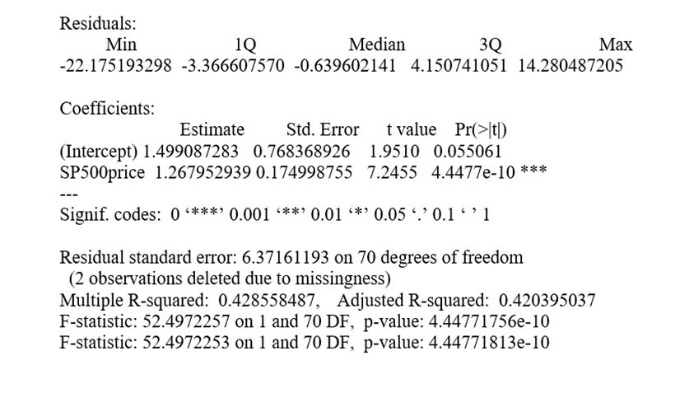

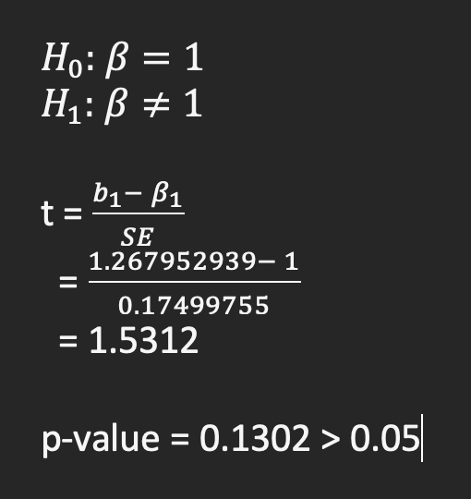

**Intel**

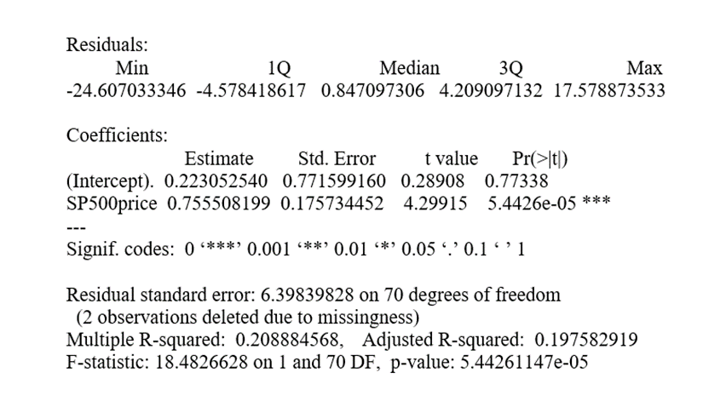

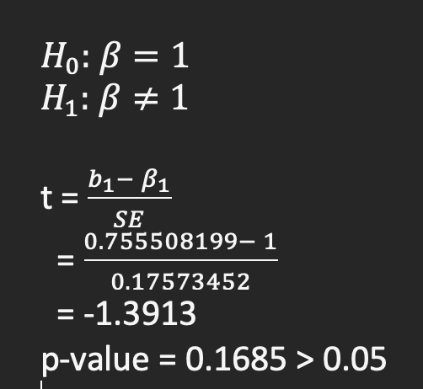 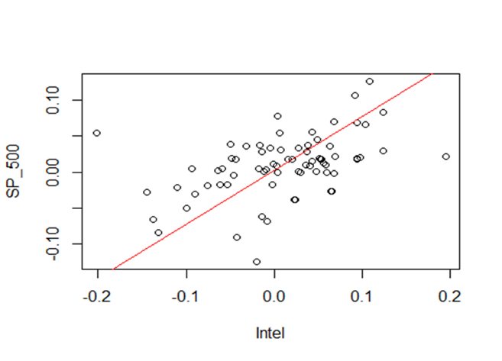

**Kroger**

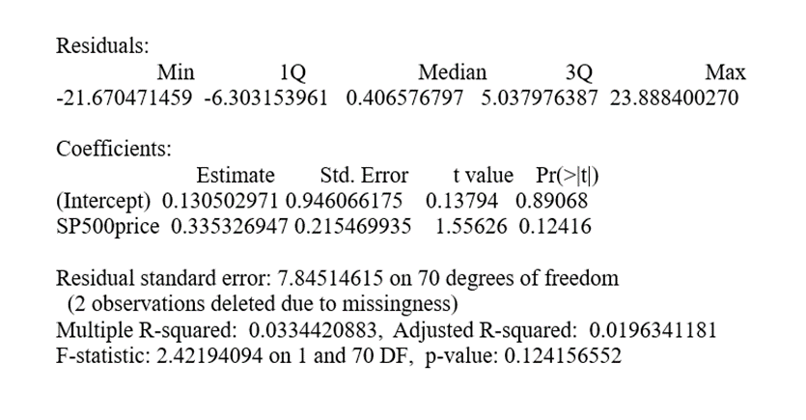

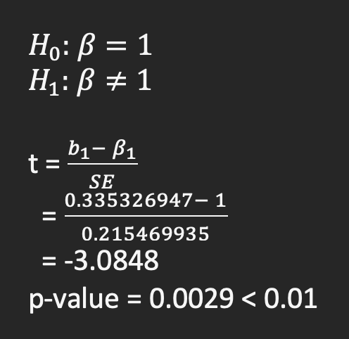 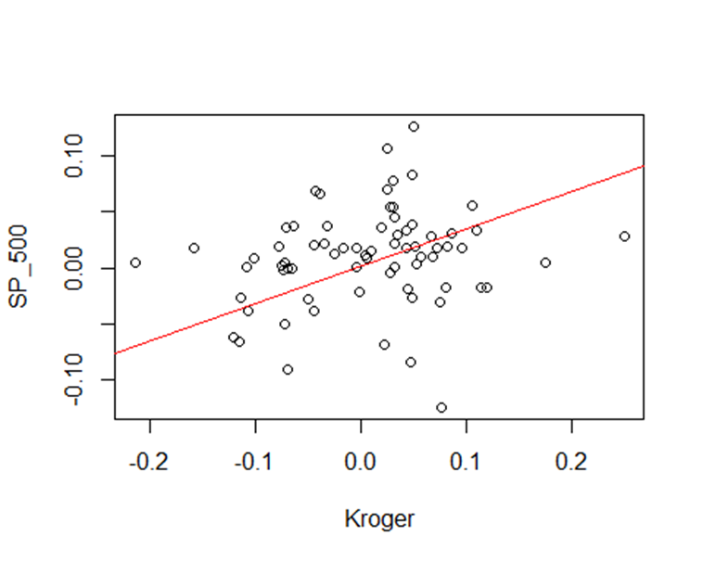

The significance of p-value in our findings measures the strength of a meaningful null hypotheses. The smaller the p-value, the stronger the evidence against the null hypothesis. A beta value of 1 means that the stock moves exactly in line with the S&P index. On the other hand, a beta value of 0 means that there is no correlation between the stock and the S&P500 index. Testing if the estimated investment beta differs from 0 provides insights whether the stock is correlated with the market. On the other hand, testing whether the estimated beta differs from 1 gives the volatility of the stock compared to the overall market, which is more meaningful in this case. A beta value greater than 1 means that the stock is more volatile than the overall market and a beta value less than 1 means that the stock is less volatile than the overall market.

Given the p-value above, we can see that Apple and Intel have p-value above 0.05, which suggests that we accept the null hypothesis since their beta is not statistically significant at 5% level. On the other hand, for Kroger, we could reject the null hypothesis at the 1% level which suggests that Kroger’s return does not align with S&P500.

When we compare the findings on the stock data in 2015-2020 with the one in 1999-2004, we have some observations – S&P, the market proxy, had a weaker return; Apple and Intel had a much more dispersed returns; and Intel had a much larger investment beta. The first two can be explained by the market events, for example, Dot-com bubble and economic effects of the 911 attacks. For the last observation, Intel, specifically, had ongoing success in sales and significant business expansion during the time period.